Configurable Software
Improvements in flexibility, scalability, affordability

By Peter Lambert, HAL Systems

This white paper describes the benefits of configurable software used to automate barcode and RFID applications. Traditional software is ‘hard-coded’ around specific applications, with the premise that a targeted solution can be applied across many users that are more or less forced to accept the assumptions and business processes of the solution provider. Changing the way a company does business is potentially an unnecessary major expense when all that is required is systemization to support a successful organization and enforce desired practices. Software should be a tool to move the company from its current state to a desired future state in a way that bridges the gap effectively and affordably. Using configurable software, the right elements (flexibility), in the right numbers (scalability), can be put in place to provide the required solution. The architecture of the software allows for only the required elements for a particular solution to be used (affordability). Configurable software can be set-up and implemented in a matter of weeks.

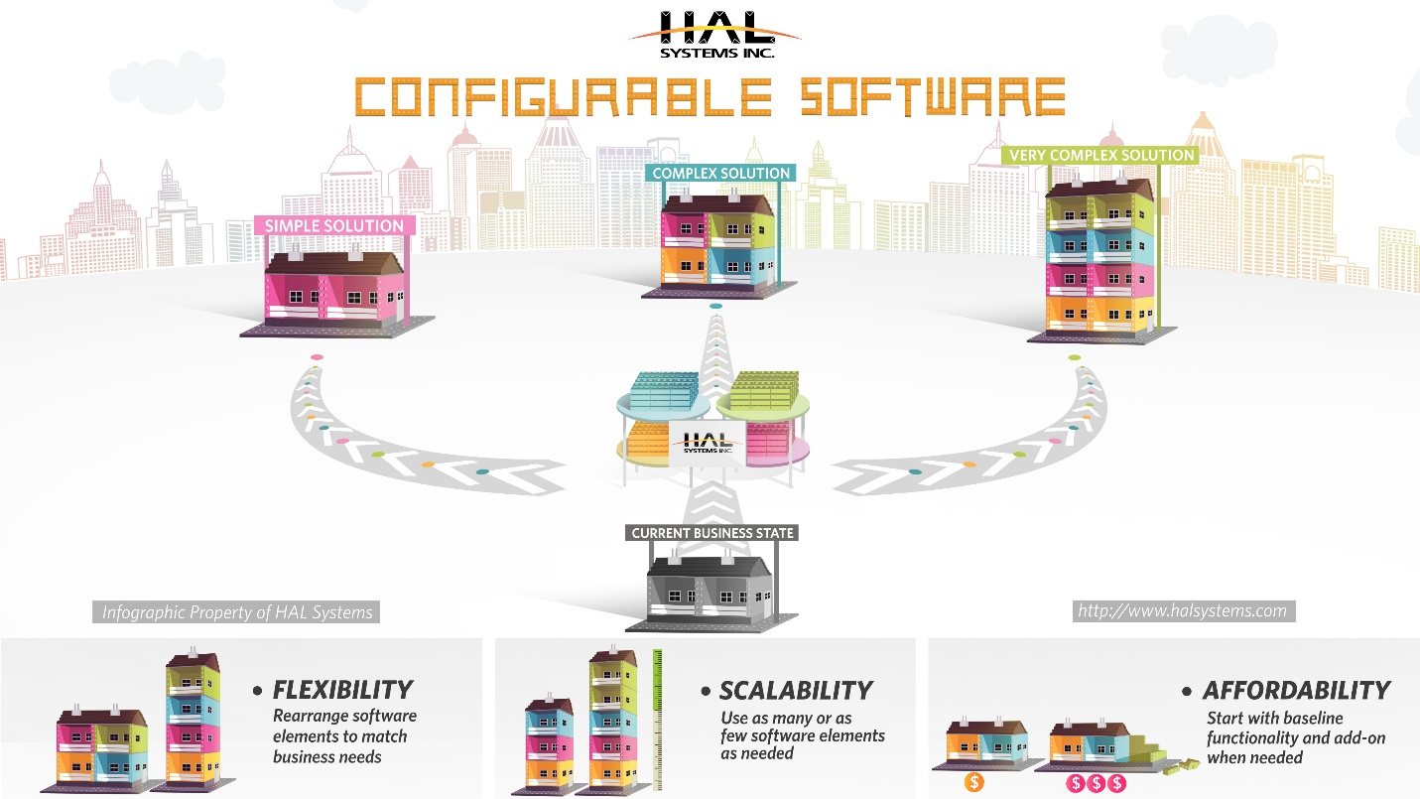

Modern software architectures have changed expectations as to the flexibility, scalability and affordability of systemization. Browser-based applications that use the web browser on hardware devices as the interface have eliminated the need for specific devices running embedded client software. This not only opens hardware selection to the entire market of devices, but also ‘futureproofs’ the system selection from being held hostage to device hardware/software limitations moving forward. It also makes convenient the delivery of the software in The Cloud using a Software-as-a-Service (SaaS) model, eliminating the need for large upfront investments and IT infrastructure. Browser-based applications contribute to simplifying network requirements – while traditional fixed Ethernet and wi-fi networks are applicable, mobile phone networks add significantly to the scope and scale of locations that can be easily operated within and also provide inexpensive back-up infrastructure.

Real time translation through a Glossary allows use of context–specific screen terms and ‘help menus’ for better understanding. This can be extended to foreign languages, where individual users can operate in different languages simultaneously. Most businesses operate using specific Business Rules, and with HAL Systems these can be easily incorporated in to the software such that the users follow the specific processes required by management. Business Rules can also be combined with Authorizations to control not only what can and can’t be done in a given situation, but by whom. And most importantly, the specific steps needed to accomplish a given operation can be easily configured using Workflows, so that the steps followed are those and only those deemed necessary by management. Valuable operator time spent performing functions designed for a different business are eliminated.

Using the benefits of configurable software, a flexible, scalable and affordable solution can be applied to many applications. Some of these include:

- Omni-channel Distribution with rules-based requirements
- Warehouse Management and inventory control in multi-facility environments
- Track & Traceability from receiving through production to distribution
- 3PL with varying requirements for different customers
- Hospital Pharmacy tracking of location/expiration/lot code of critical medications
- Asset Tracking of critical service equipment requiring calibration
- Refillable Tank tracking between refill and customer locations
- Rental Asset tracking for wedding receptions, concerts, etc.
- Check-In/Out of barcode scanners and other valuable hardware
- Data Collection of consigned inventory at customer sites
- Football Helmets with RFID-encoded child emergency information

There is no end to the applications that can be addressed by the flexibility and scalability of configurable software. It is simply a matter of using the right number of the right elements to move a business from their current state to a desired future state. By making this affordable, most businesses can enjoy the many operational and cost benefits that will help them succeed in an ever more globally competitive world.

